**EXPNO 4**

**DATE:09/02/2023**

**CREATE A SNAPSHOT AND CLONING OF A VM AND TEST IT BY LOADING THE PREVIOUS VERSION/CLONED VM**

**AIM:**

To create a snapshot and cloning of a vm and test it by loading the previous version/cloned vm

**PROCEDURE:**

1. Goto vmware workstation
2. Create files on desktop
3. Click on vm and selects snapshot-> take snapshot.
4. Snapshot is being done
5. Go to vm and goto manage and click clone
6. Click clone
7. Select the full clone
8. After clone again or vm is opened.

**IMPLEMENTATION:**

**STEP 1: GOTO VMWARE WORKSTATION**

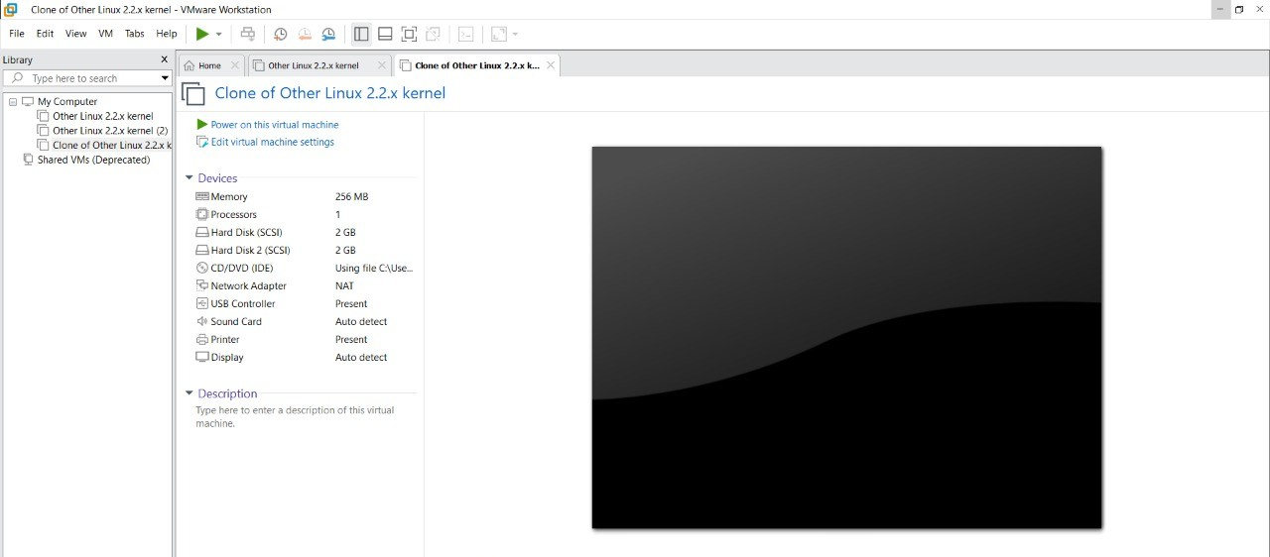

**STEP 2: CREATE FILES ON DESKTOP**

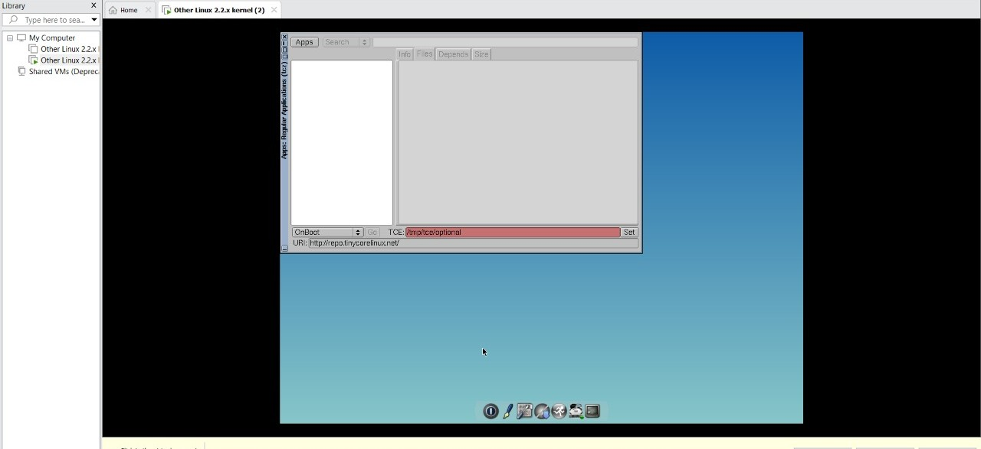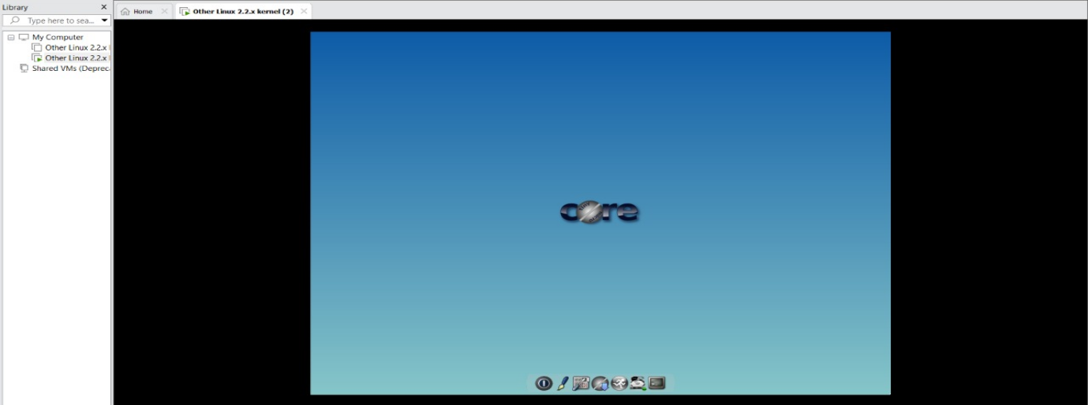

**STEP 2: CLICK ON VM AND SELECTS SNAPSHOT-> TAKE SNAPSHOT.**

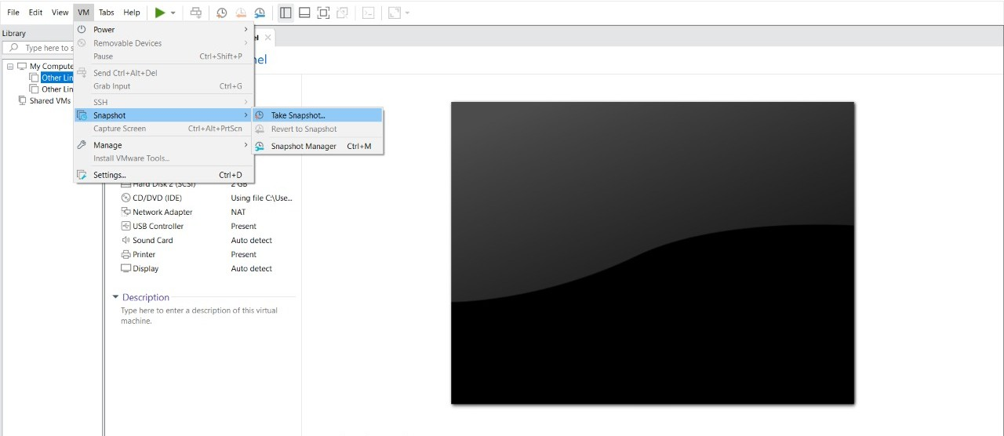

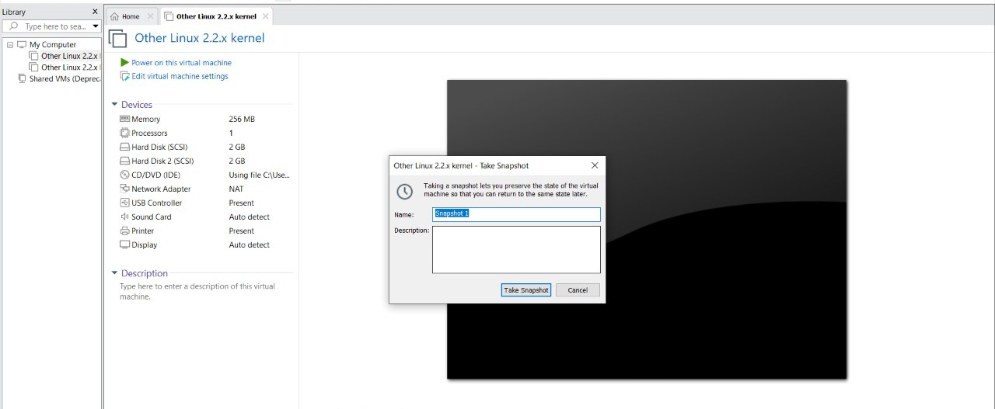

**STEP 4: SNAPSHOT IS BEING DONE**

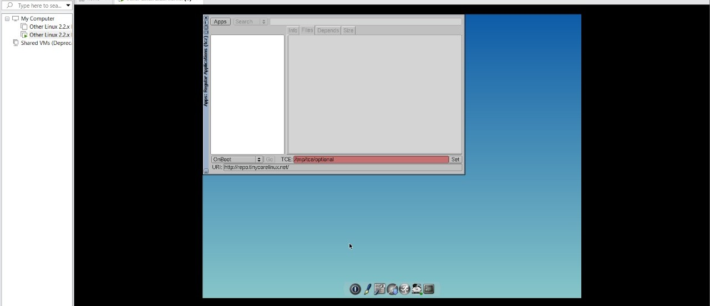

**CLONING OF A VM**

**STEP 1: GO TO VM AND GOTO MANAGE AND CLICK CLONE**

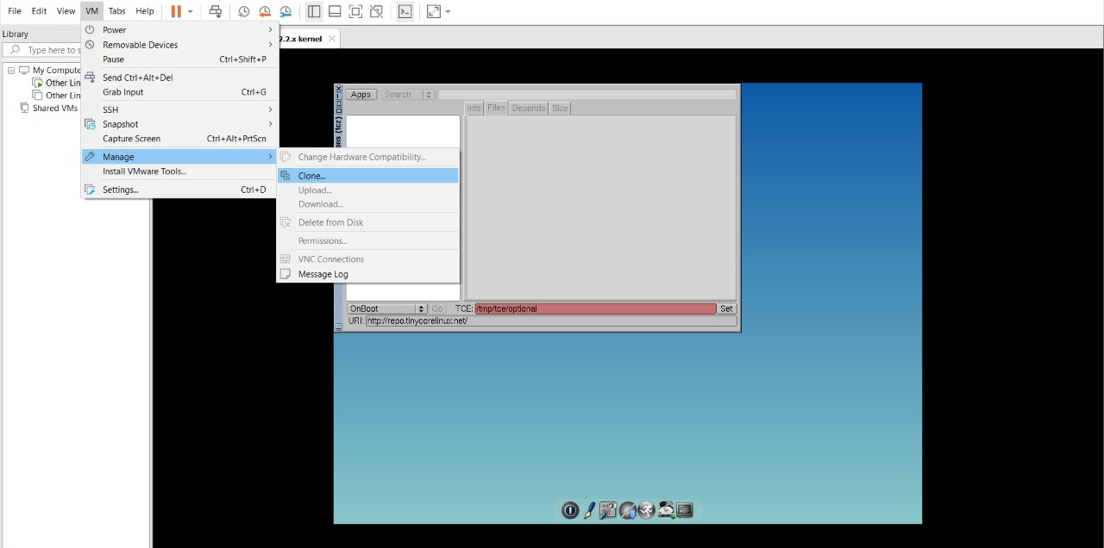

**STEP 2: CLICK CLONE**

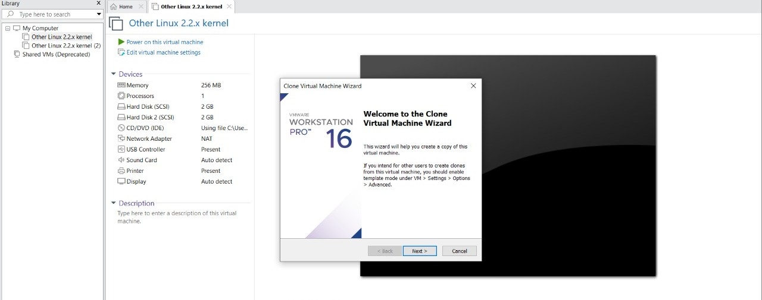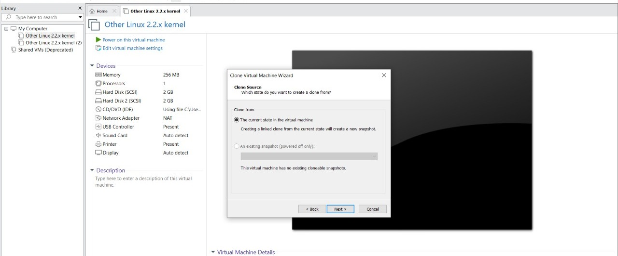

**STEP 3: SELECT THE FULL CLONE**

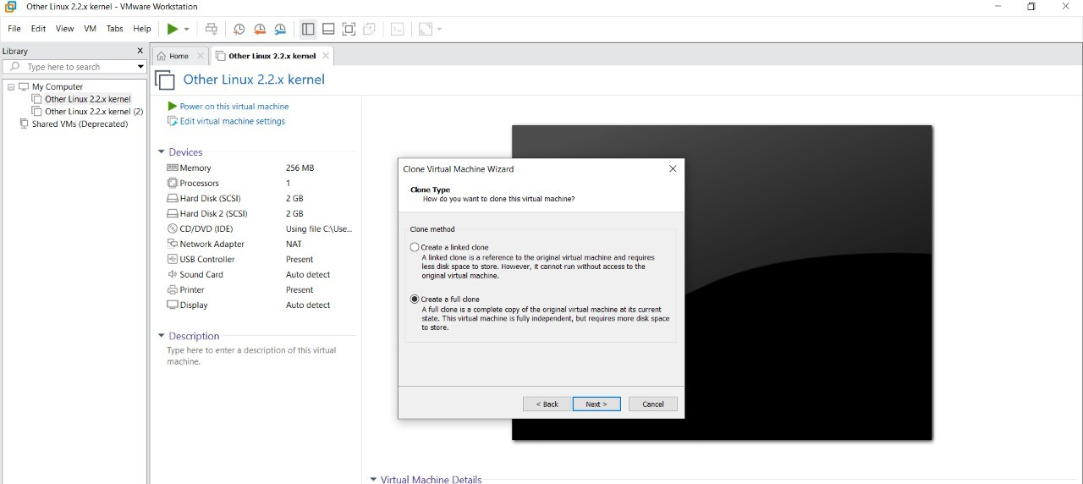

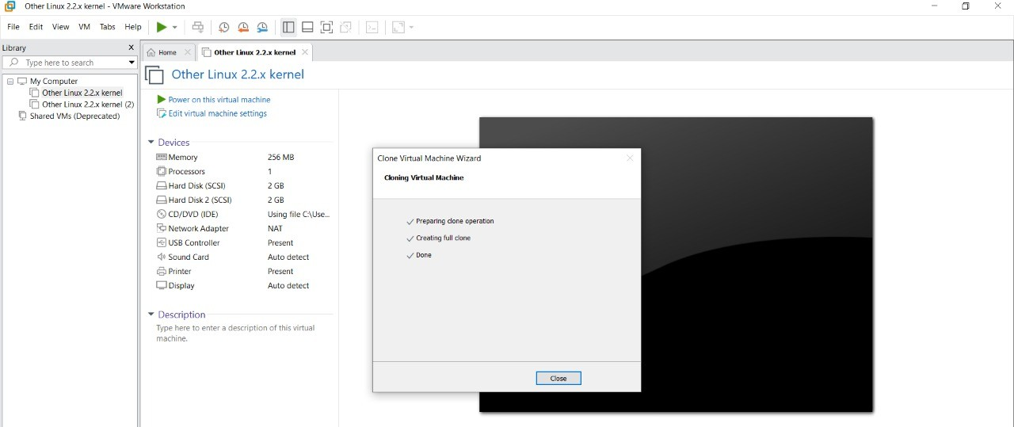

**STEP 4: AFTER CLONE AGAIN OR VM IS OPENED.**

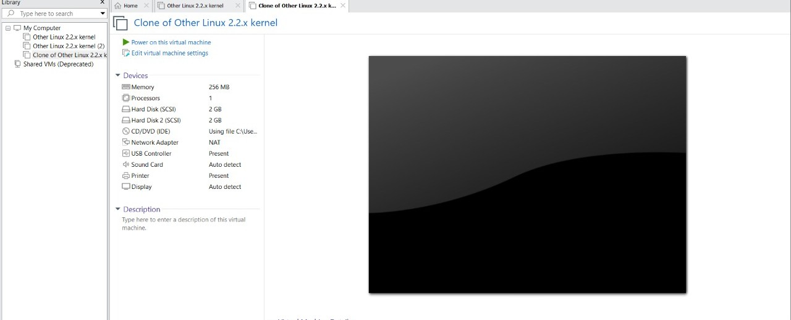

**OUTPUT**

**1.SNAPSHOT**

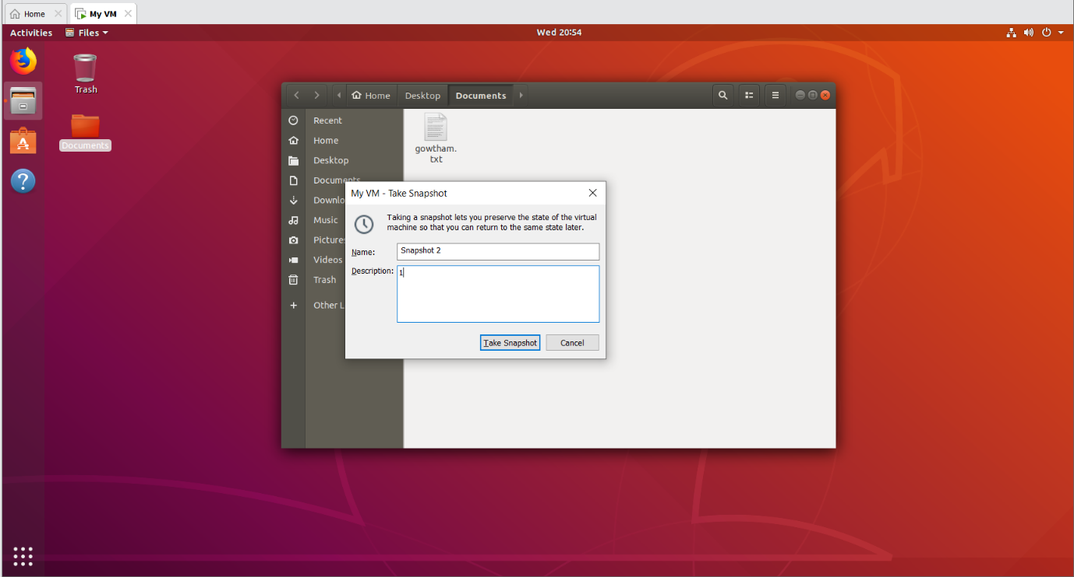

**2.CLONING**

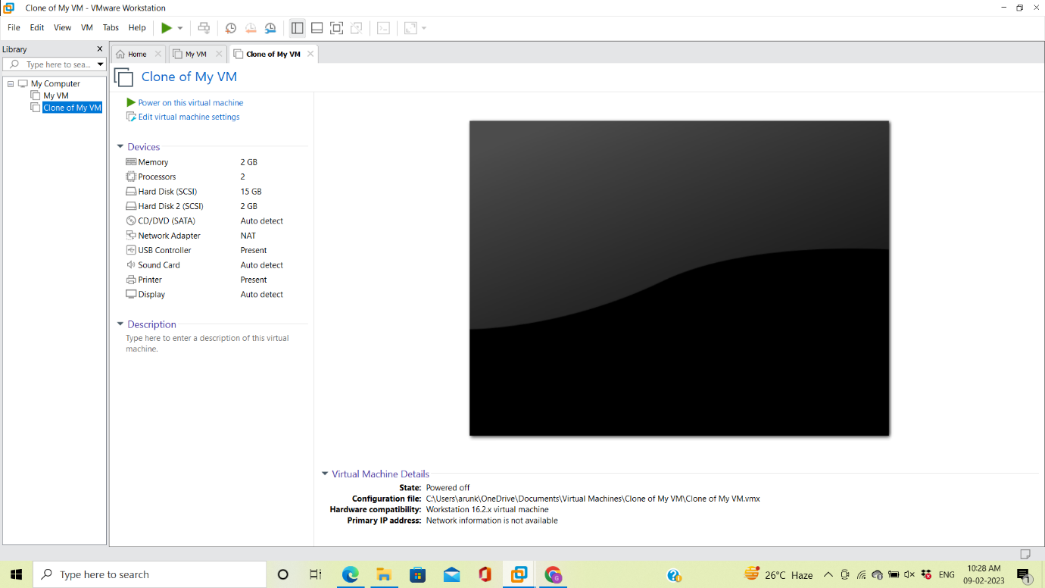

**RESULT**

Hence creation of a snapshot and cloning of a vm and test it by loading the previous version/cloned vm is performed successfully in VM ware.